1.0 Objectives
In this lab you will recreate the 8-bit 2-to-1 bus multiplexer from the i281e processor on a breadboard. This lab also covers the concepts of hardware buses, hardware circuit standardization, and connectors.

2.0 Parts List
Quantity | Item
1 | White 830-point Breadboard
Set of | Breadboard Wire Spools | Or you can use a Pre-Cut Wire Kit
1 | Wire Cutters Electronic Grade
1 | Wire Strippers Electronic Grade
2 | Quad 2-to-1 MUX Chip (SN74HCT257N)
2 | 0.1 μF Ceramic Capacitor
1 | 5mm Yellow LED
1 | 330 Ω THT Resistor
6 | Connector for 16-position ribbon cable, DIP Header Connector (FDP-316-T)
3 | 16-Conductor Ribbon Cable, 8 to 12 inches long (AWG28-16/G/300)
1 | Breadboard Power Supply (e.g, YwRobot MB-V2)

3.0 Background

3.1 8-bit Buses
We will implement an 8-bit bus with a 16-conductor ribbon cable. This cable has twice as many wires than we need, so half of them will remain unused. Figure 1 shows the mapping of the wires to the 16-position connector. The unused wires are labeled with G or GND because they are typically set to ground. By convention, the red wire indicates the least significant bit. Figure 2 shows the pins of the end connector that is designed to plug into a breadboard. The pin numbers indicate the position of the bits in the 8-bit bus. Figure 3 shows the finished cable, with the connectors attached.

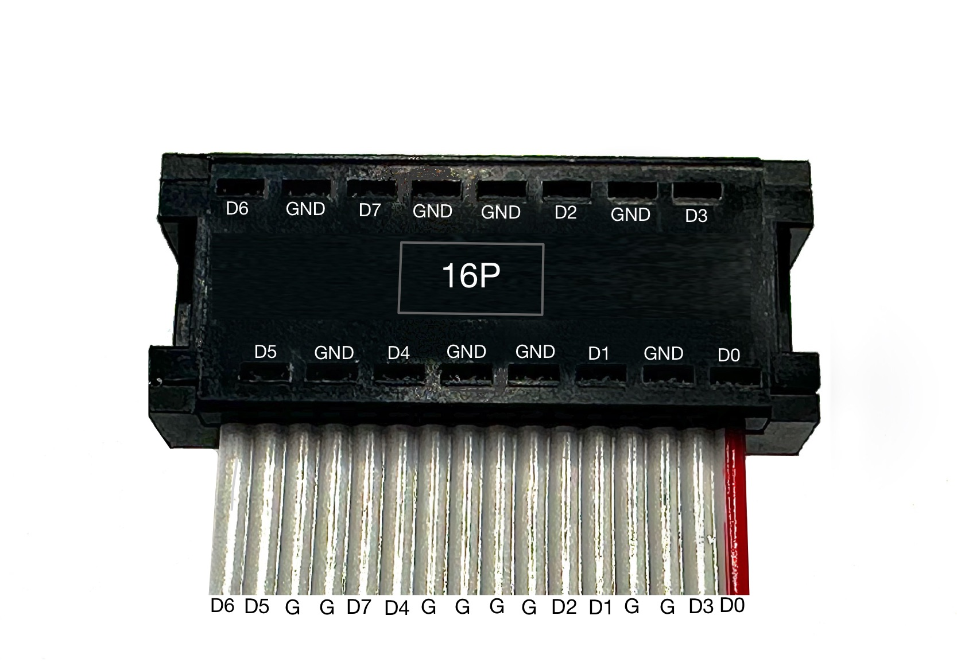
Figure 1: Standardized mapping of an 8-bit bus to a 16-conductor ribbon cable.

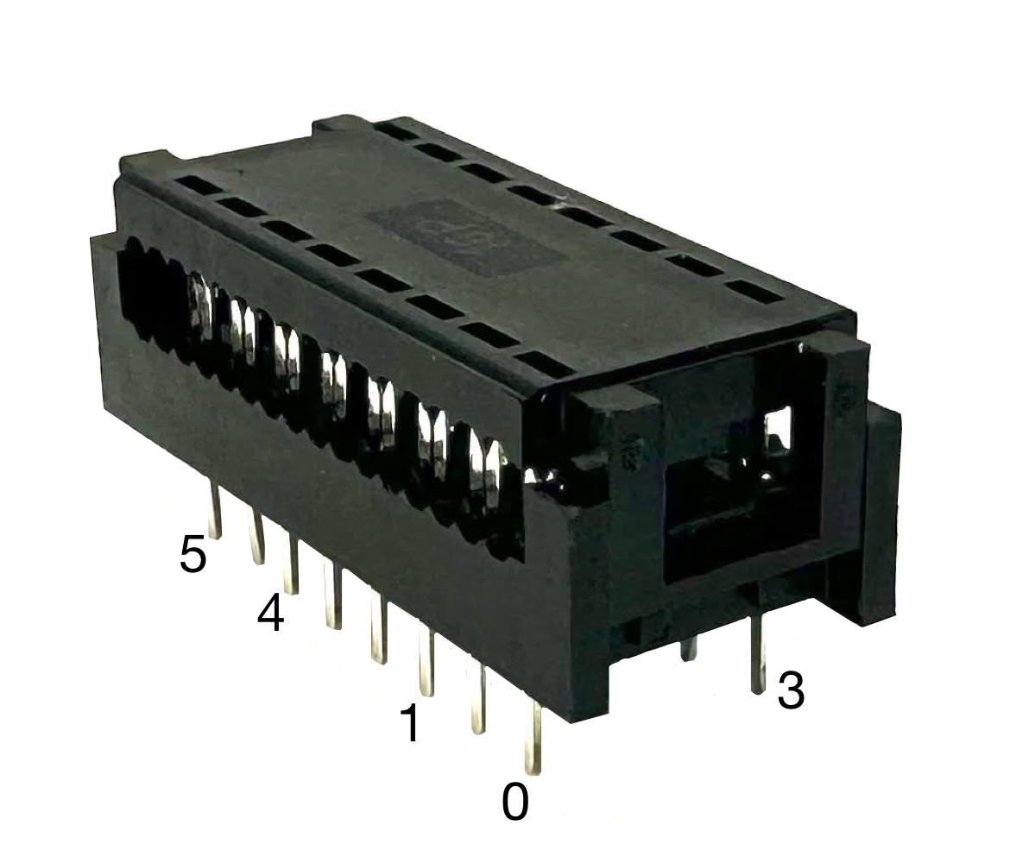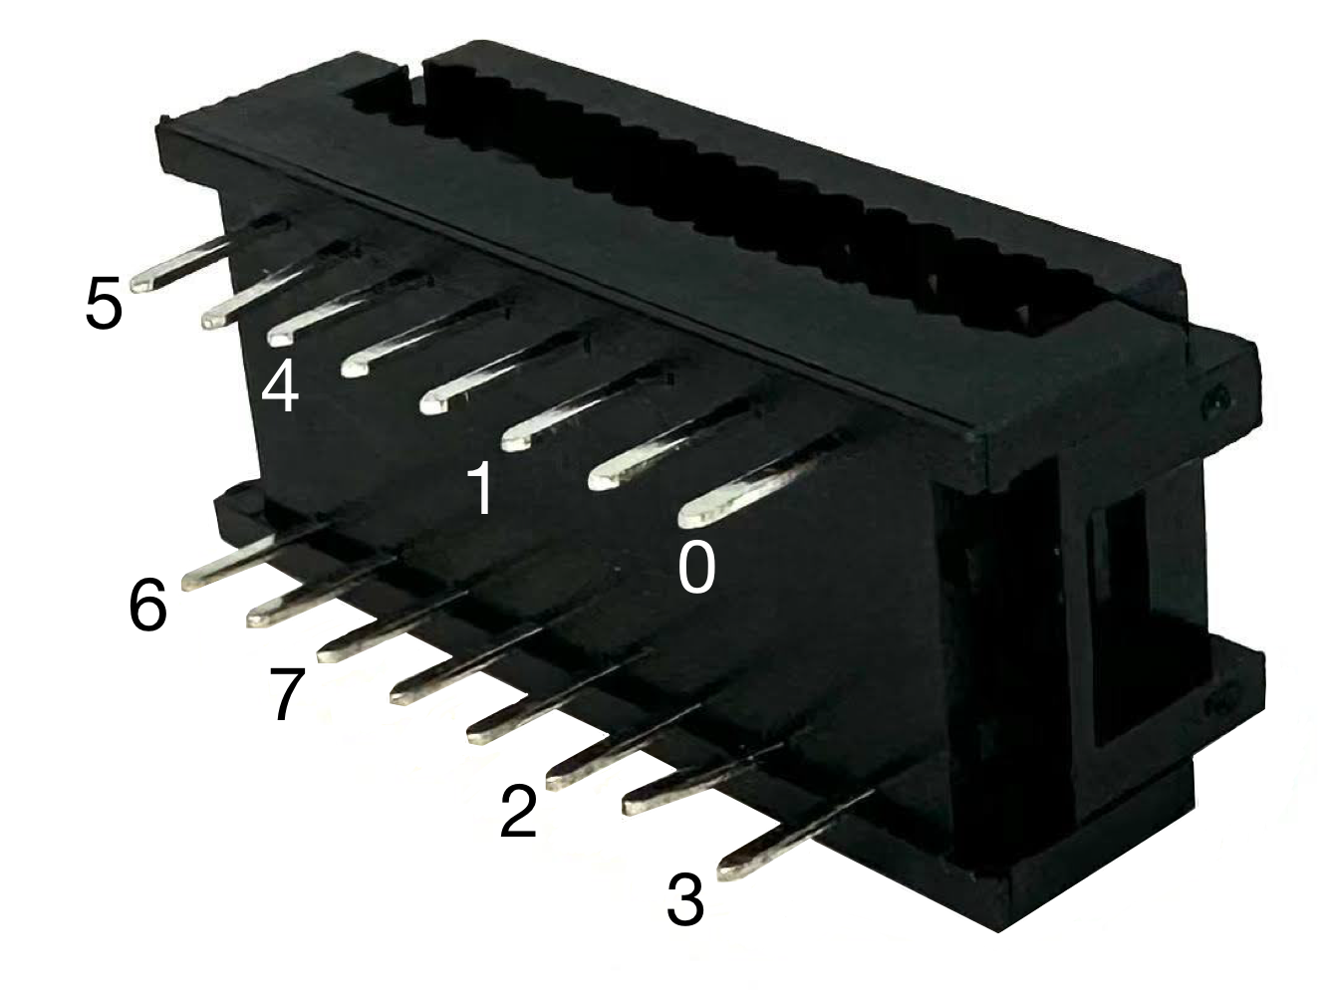

Figure 2: Side view of the connector pins.
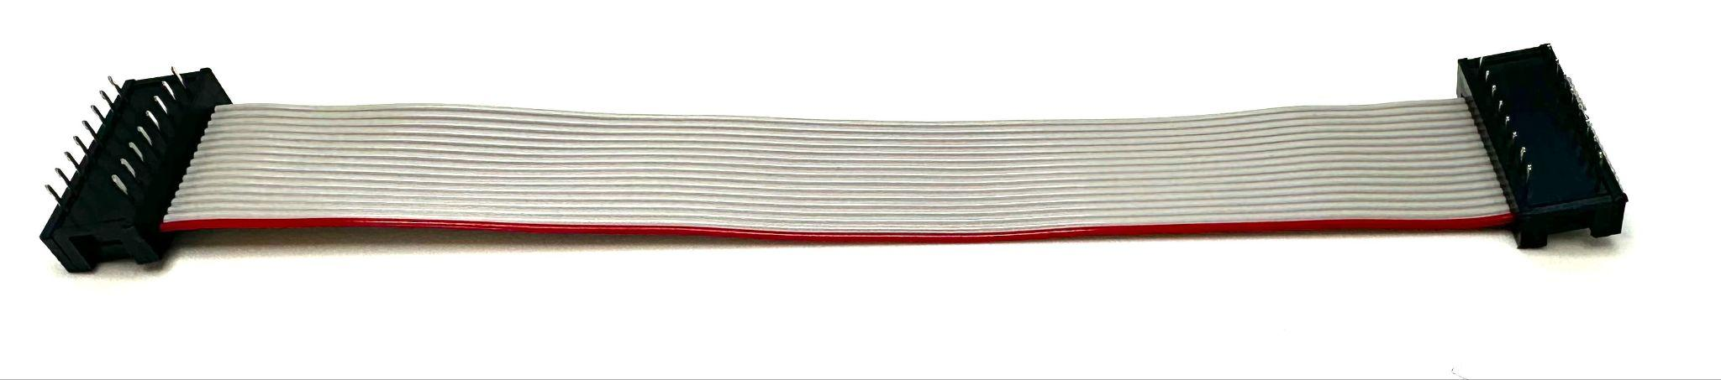
Figure 3: An 8-bit bus with connectors on both sides.

3.2 Implementation
An 8-bit 2-to-1 bus MUX is typically drawn as shown in Figure 4. Figure 5 expands this diagram to show the individual 2-to-1 multiplexers, which have the same select input.
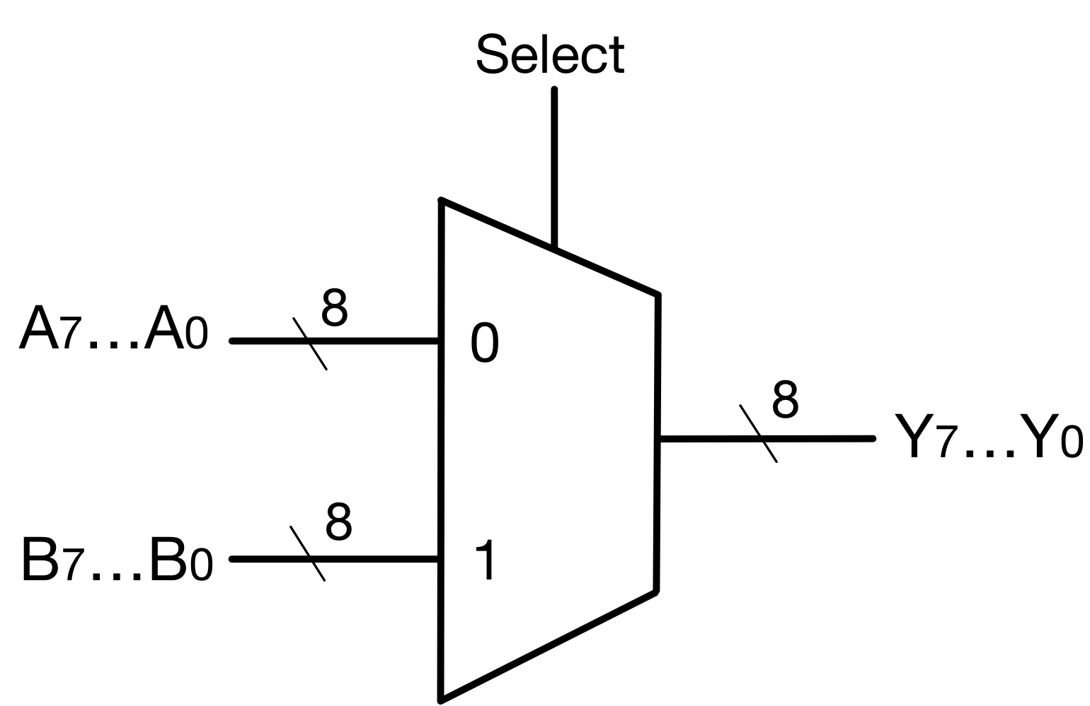
Figure 4: Graphical symbol for a 2-to-1 bus MUX (8-bits wide).

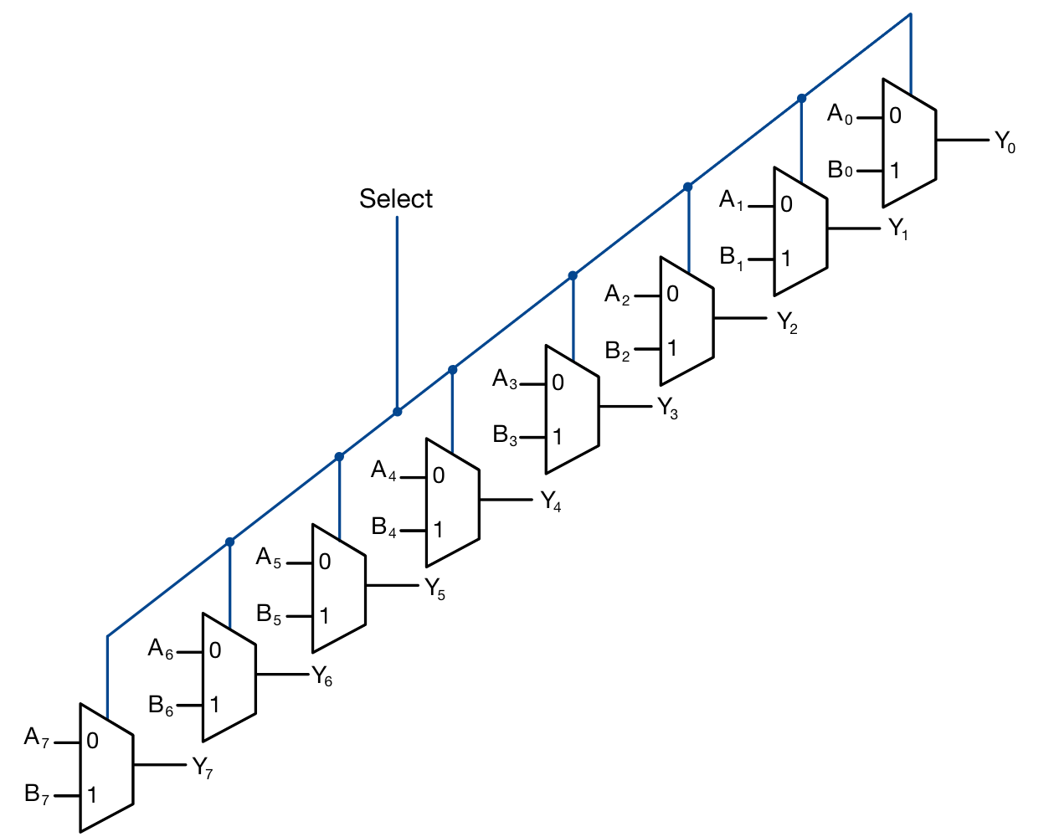
Figure 5: Expanded wiring diagram for the bus MUX from Figure 4.
To implement the 8-bit 2-to-1 bus multiplexer, you will use two SN74HCT257N chips. As shown in Figure 6 each of them contains four 2-to-1 multiplexers that share the same select line ($\underline{A}/B$). To complete the entire circuit, you need to combine the two chips and configure them to choose between the two input buses A = (A₇ … A₀) and B = (B₇ … B₀), depending on the value of the common select line. The output bus is called Y = (Y₇ … Y₀). Don’t forget to set the output enable line ($\underline{OE}$) of each chip to 0. Please refer to the datasheet for additional information.

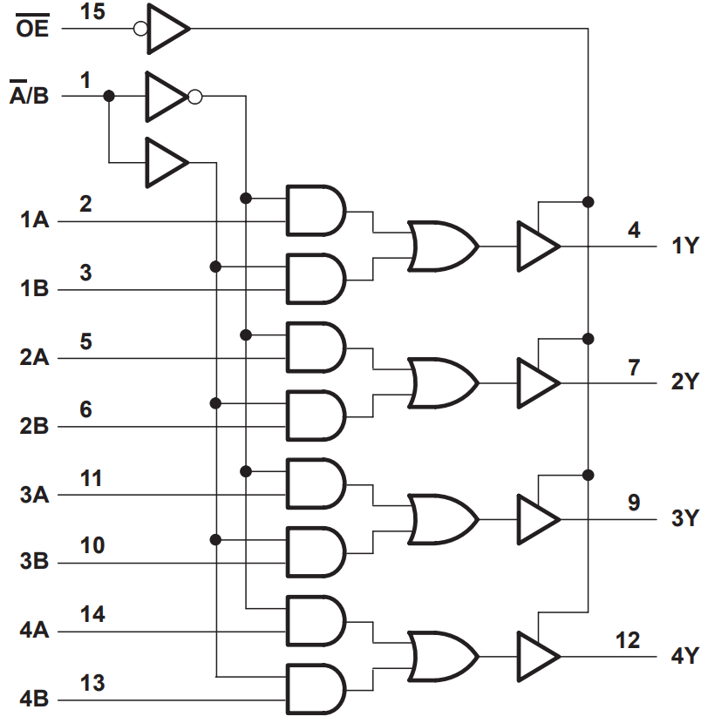
Figure 6: Pin layout for the Quad 2-to-1 MUX Chip (SN74HCT257N). From the spec sheet.

3.3 Standardization
When implementing circuits for this class, please follow these breadboard conventions:
- Each breadboard has an orientation, imposed by the numbers printed on it. In the correct orientation you must be able to read the numbers. (i.e., they are not upside down). Also, the positive power rail must be on top.
- Red wires are only for powering components, while black wires are for grounding.
- The red wire on each ribbon cable represents the least significant bit of the bus (i.e., it should be on the right side when looking at the ribbon cable in the correct orientation).
- When visualizing an 8-bit binary number with LEDs, the least significant bit should always be on the right side when you look at the breadboard from the correct orientation.

4.0 Activity
Please complete the pre-lab before starting with the lab. Specifically, you need to understand the purpose of the chips and the labels of the pins.

4.1 Place the Bus Connectors and the Chips
- Place the chips as shown in Figure 7.
- Connect them to power (pin 16) and ground (pin 8).
- Connect $\underline{OE}$ (pin 15) to ground. This enables the output of the chip.
- Connect the top power rail of the breadboard to the bottom power rail with a red wire. Also, connect the two ground rails with a black wire.
- Place the three bus connectors as shown in Figure 7. Don’t insert the ribbon cables and don’t press together the two parts of the connector yet.
- Study Figure 8, which is a simulated version of Figure 7. The pins of the connectors are labeled with small numbers. The red 0 indicates the position of the least significant bit of the corresponding bus.
Before continuing to the next step, have your circuit checked by the TA.
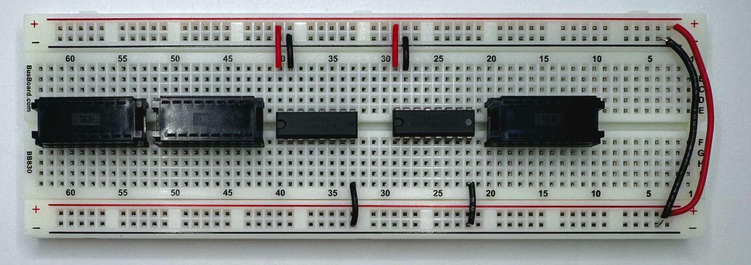
Figure 7: Image of a real breadboard with connectors and chips inserted in place.

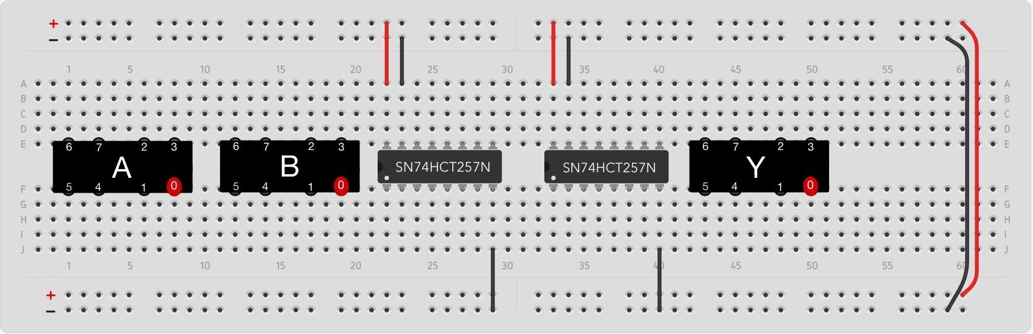
Figure 8: Image of a simulated breadboard that is equivalent to Figure 7.

4.2 Connect the Most Significant Bits of Both Inputs to the First Chip
- First, connect bits B6 and B7 to the left MUX chip at pins 10 and 13 (shown in Figure 9 as the top set of green wires).
- Next, connect A6 and A7 to pins 11 and 14, respectively. See the top set of blue wires.
- Repeat these steps for the bottom. Connect B5 and B4 to pins 6 and 3 (green wires), then A5 and A4 to pins 5 and 2 of the left chip (blue wires).
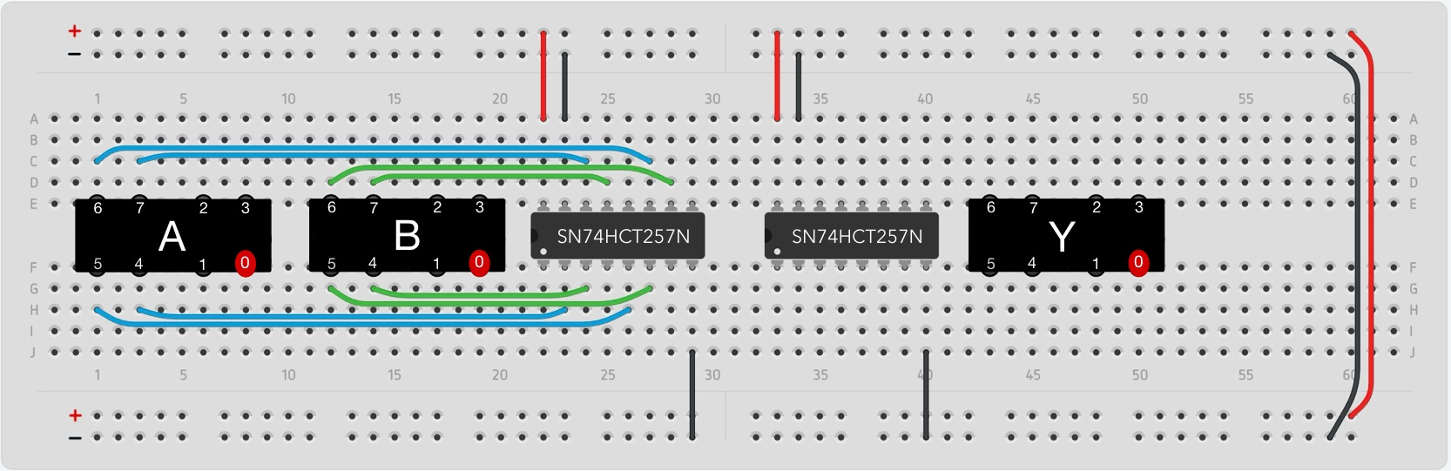
Figure 9: Connect the most significant input bits.

4.3 Connect the Least Significant Bits of Both Inputs to the Second Chip
- First, connect bits B2 and B3 to the right MUX chip at pins 10 and 13 (shown in Figure 10 as the top set of green wires).
- Next, connect A2 and A3 to pins 11 and 14, respectively. See the top set of blue wires.
- Repeat these steps on the bottom to connect B1 and B0 to pins 6 and 3 (green wires), then connect A1 and A0 to pins 5 and 2 of the right chip (blue wires).
Have the TA verify your new connections before proceeding.
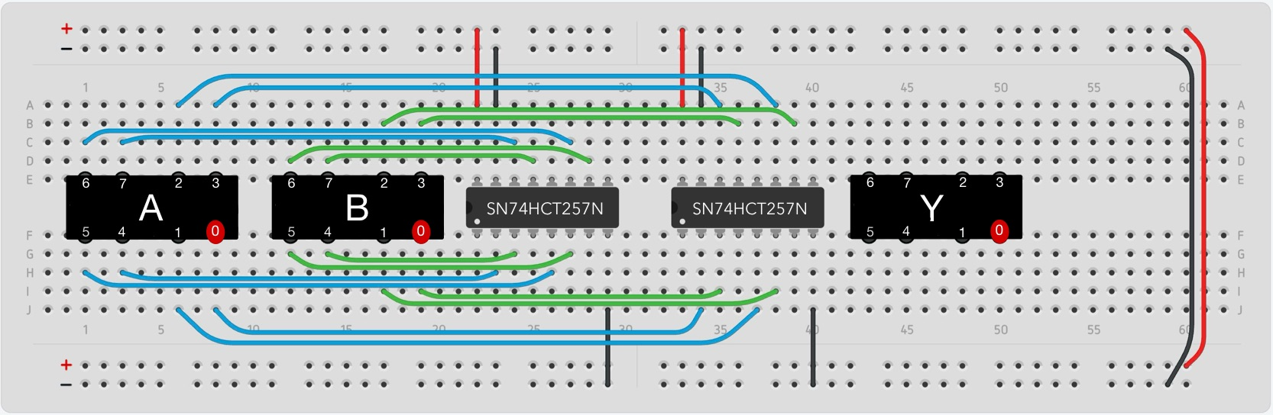
Figure 10: Connect the least significant input bits.

4.4 Connect the Chips to the Output Bus
Start by connecting the four most significant bits (left chip) to the output connector:
- Top: Connect pins 9 and 12 of the chip to bits Y6 and Y7, respectively.
- Bottom: Connect pins 4 and 7 of the chip to bits Y4 and Y5, respectively.
Next, connect the least significant bits (right chip) to the output connector:
- Top: Connect pins 9 and 12 of the chip to bits Y2 and Y3, respectively.
- Bottom: Connect pins 4 and 7 of the chip to bits Y0 and Y1, respectively.
Your circuit should be similar to the one shown in Figure 11.
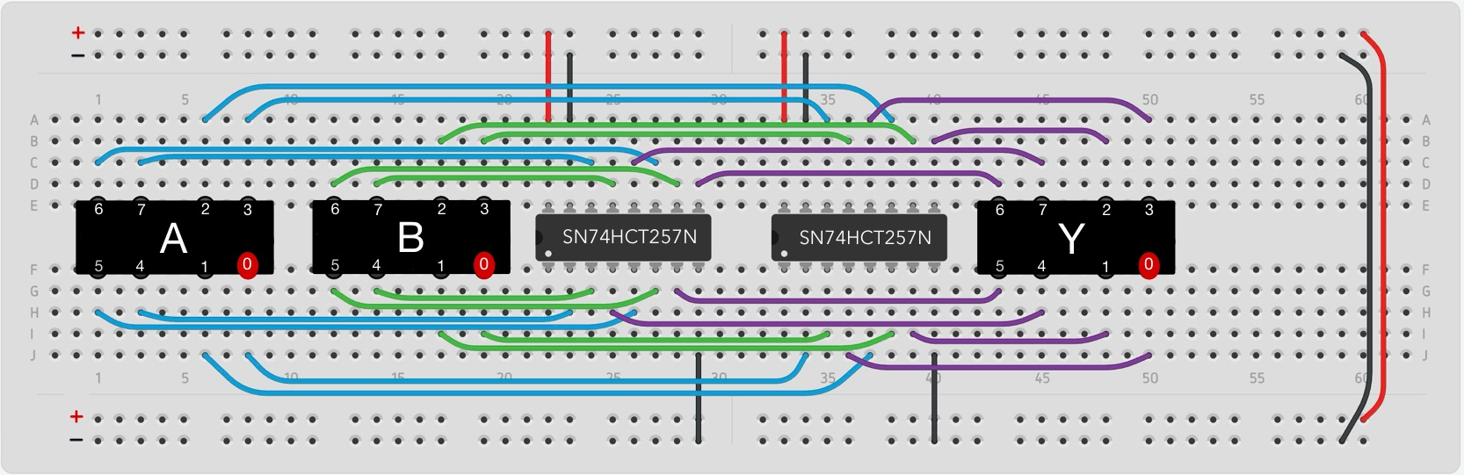
Figure 11: Connect the chips to the output bus (purple wires).

4.5 Finish the Circuit
- Place an LED on the right side of the circuit and ground its cathode (shorter leg).
- Connect the anode of the LED to a 330 Ω resistor.
- Connect the other side of the resistor to both chips at pin 1 (yellow wires in Figure 12).
- Connect that same side of the resistor to the select line, which may be grounded for now but will come from the test circuit later.
- Finally place two 0.1 µF capacitors to connect pin 16 of each chip to ground. Because in this case pin 15 is already grounded, the capacitor can connect pin 16 to pin 15.
Show your completed circuit to the TA before continuing.
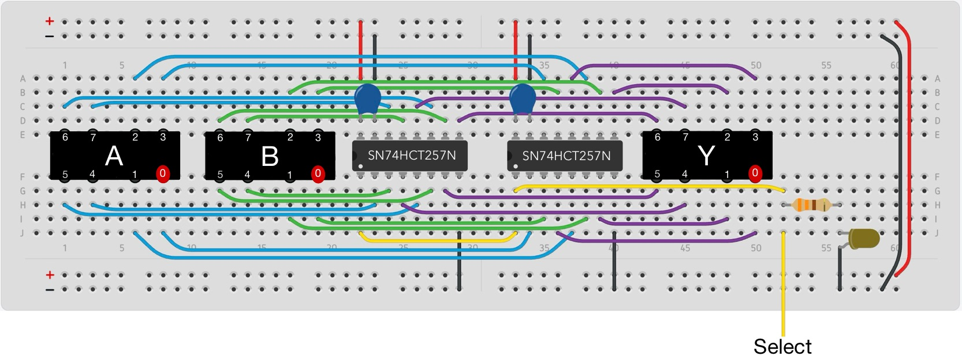
Figure 12: Add the select line and visualize it with an LED.

4.6 Make Three Ribbon Cables with Connectors
- Place a connector on an empty breadboard.
- Next, insert a ribbon cable into the top part of the connector. Ensure that each pin of the connector is in contact with exactly one wire from the ribbon bundle.
- Once the ribbon is positioned correctly, firmly press down with a flat object until the two parts of the connector click into place.

4.7 Connect the Ribbon Cables to the Bus MUX Circuit
- Figure 13 shows the completed real circuit that corresponds to Figure 12. It uses 3 connectors as placeholders. They are not connected to anything at this point.
- Start with the breadboard upright (the numbers are upright facing you) and replace each connector with a connector that already has a ribbon cable attached to it.
- The three ribbons should go out the bottom of the breadboard with the red wires on the right-hand side.
- The result should look like Figure 14.
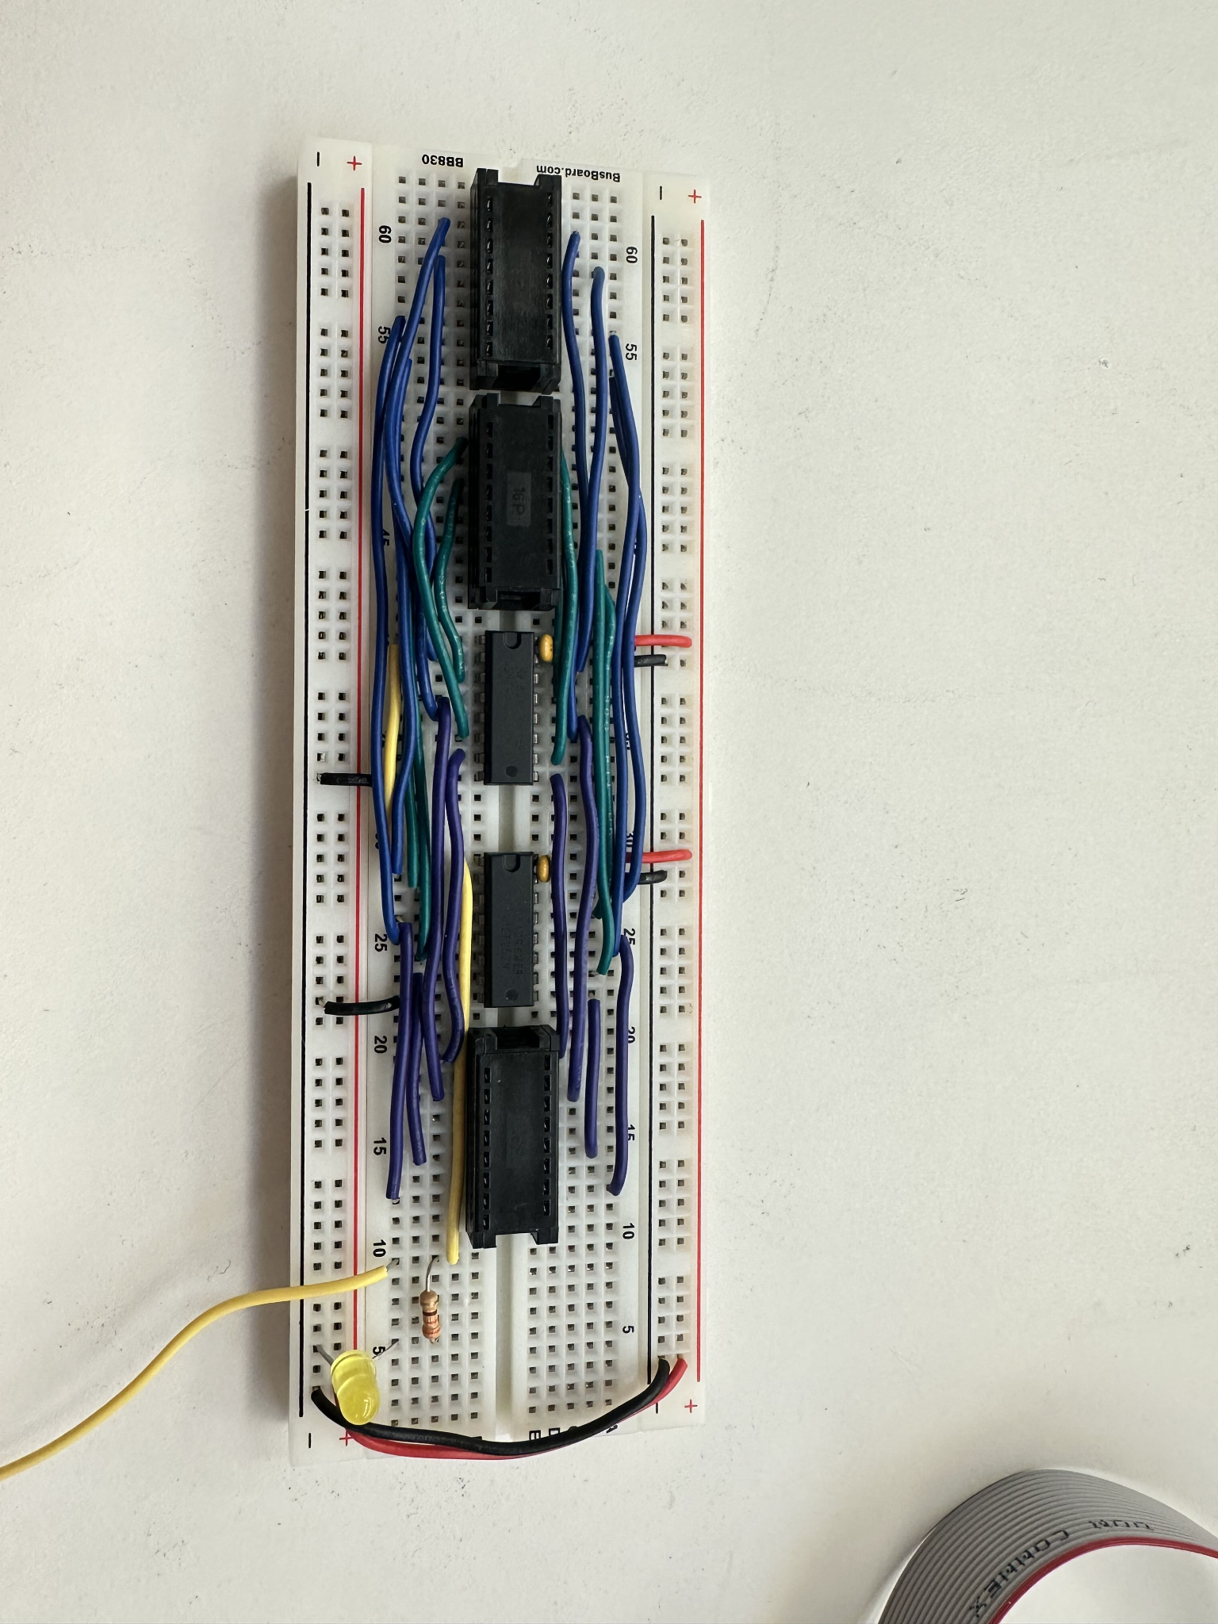
Figure 13: The finished bus MUX with place-holder connectors.

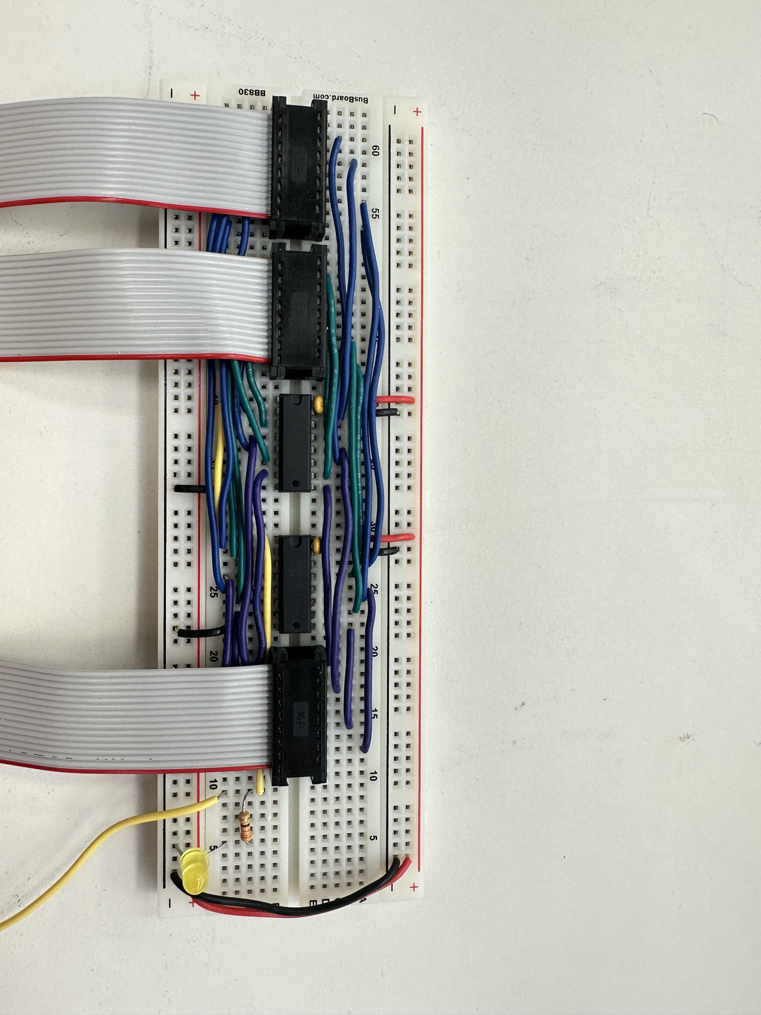
Figure 14: The finished bus MUX with ribbon cables attached.

5.0 Testing
Figure 15 shows the circuit that you will use to test your bus MUX. The connectors labeled A and B are for the input buses of the MUX. The one labeled Y is for the output bus. The first set of eight switches (upper-left corner) provide the bits for the A bus. The second set of eight switches do the same for the B bus. The other breadboard contains switches for the select line and LEDs for visualizing the output (the Y bus).

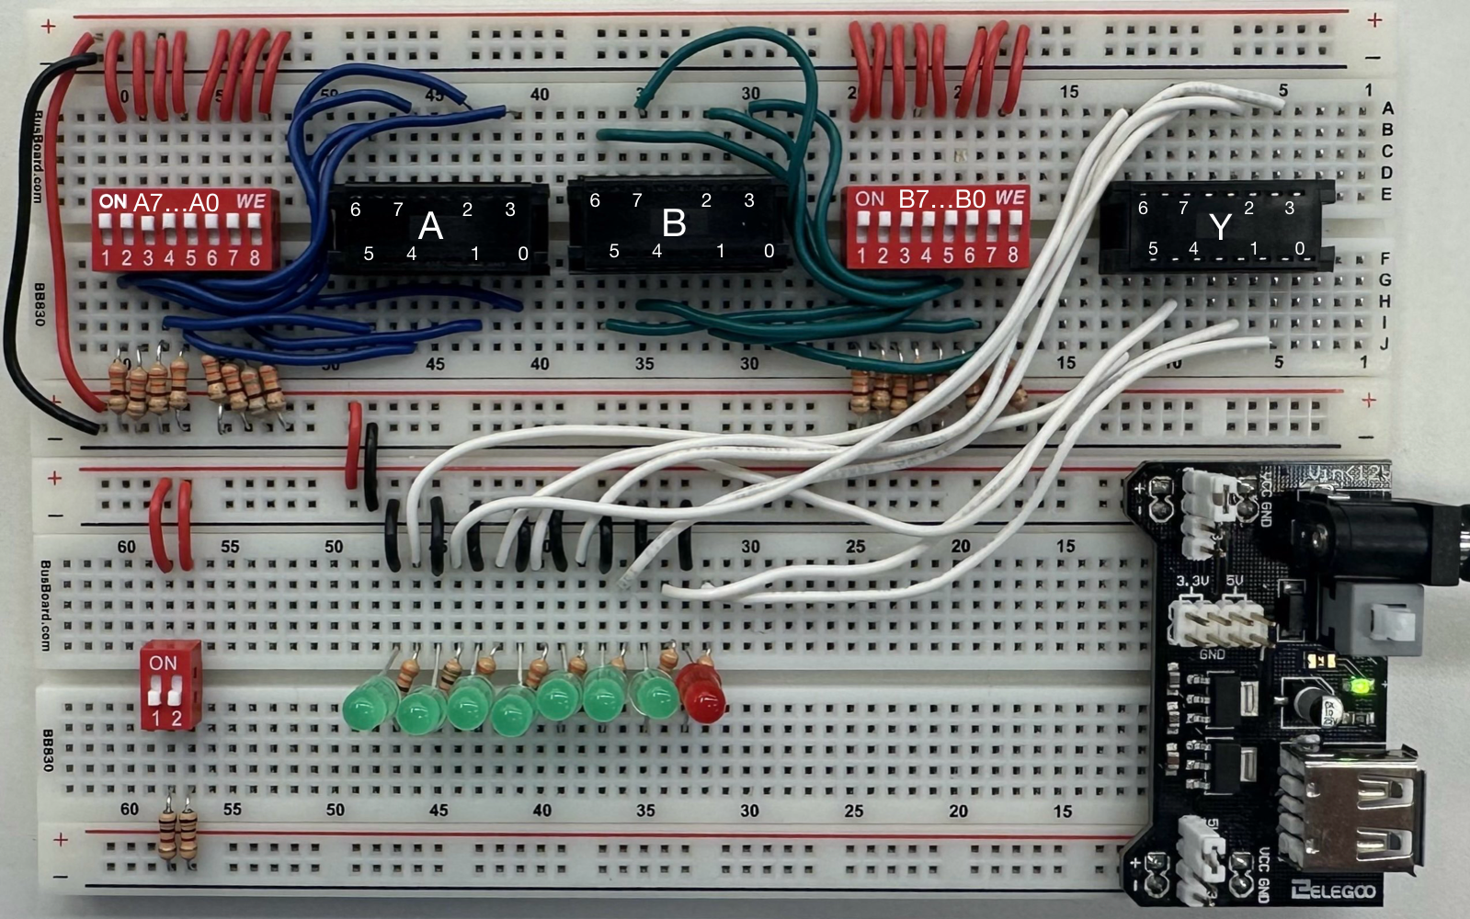
Figure 15: Tester circuit.

5.1 Connect the Ribbon Cables to the Tester Circuit
- Place your bus MUX circuit above the tester circuit. Connect the leftmost ribbon cable of the tester to the A input of the MUX.
- Repeat this for bus B and the output bus Y.
- Next, connect the select line of the MUX to the tester circuit. To do this, use the yellow select wire that was grounded in step 4.5 and connect it to the small DIP switch.
- Finally, connect the power and ground rails of the tester circuit to the rails of the breadboard with your MUX circuit (see Figure 16). This will ensure that both circuits are powered.

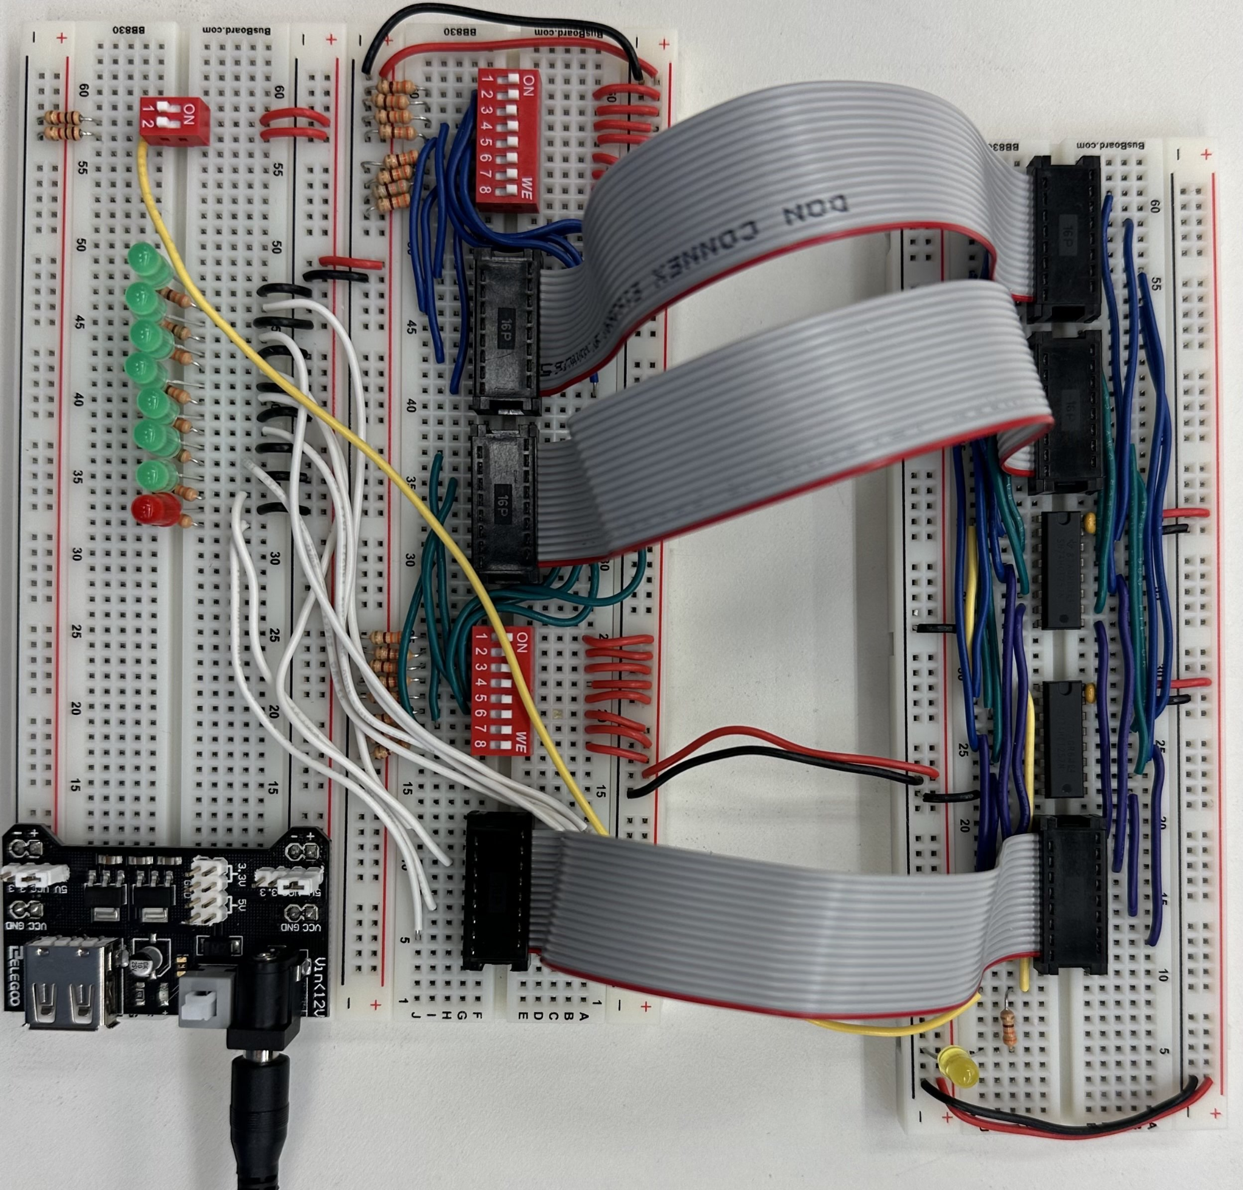
Figure 16: Bus MUX circuit connected to the tester circuit.

5.2 Test the Bus MUX
- Power the tester circuit using a breadboard power supply.
- Ensure that when the select line is low, the output shows the value of input A from the first eight switches. Similarly, when select is high, the output must show the value of input B from the second eight switches.
Once you have completed and recorded the results of each test, perform each test for the TA.

